**Bellringer**: Constructing a Phylogenetic Tree

AP Biology

Phylogeny is the evolutionary history of a species.

1. The evolution of a species is dependent on changes in the genome of the species. Identify TWO mechanisms of genetic change, and explain how each affects genetic variation.
2. Based on the data in the table below, draw a phylogenetic tree that reflects the evolutionary relationships of the organisms based on the differences in their cytochrome c amino-acid sequences and explain the relationships of the organisms. Based on the data, identify which organism is most closely related to the chicken and explain your choice.

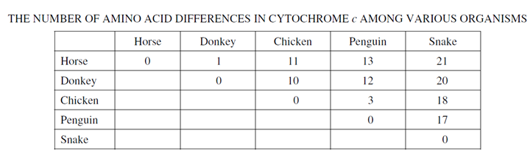

**Bellringer**: Constructing a Phylogenetic Tree

AP Biology

Phylogeny is the evolutionary history of a species.

1. The evolution of a species is dependent on changes in the genome of the species. Identify TWO mechanisms of genetic change, and explain how each affects genetic variation.
2. Based on the data in the table below, draw a phylogenetic tree that reflects the evolutionary relationships of the organisms based on the differences in their cytochrome c amino-acid sequences and explain the relationships of the organisms. Based on the data, identify which organism is most closely related to the chicken and explain your choice.

